WEEK 9
Date of preparation: October 19th , 2019
Date of teaching: October 21st , 2019
Class: 3A and 3C
Period 35 REVIEW 1 ( con’t)

- Read and match:
- Who’s |  | - Are you?
- It’s |  | - Years old.
- How old |  | - That?
- I’m six |  | - Miss Hien.
- Match the sentences:
- Who’s that? |  | - Yes, it is.
- How old are you? |  | - It’s Mr. Loc.
- Is that Mai? |  | - She’s eight years old.
- How old is Mai? |  | - I’m eight years old.
- Put the words in order. Then read aloud:
- That/ Mai/ is
- You/ old/ how/ are
- Nine/ old/ I’m/ years
- Mai/ how/ is/ old
- Read and complete: Old, that, no, are
- A: Is that Linda?
B: (1) ..................................... , it isn’t.
A: Who’s (2) ..................................... ?
B: It’s Mary.
- A: How old (3) ..................................... you?
B: I’m ten years (4) ..................................... .
- Write about you:
- What’s your name?
How old are you?
Ex 1. Hoàn thành các từ sau, sử dụng L hoặc A
1. ....inda 4. N....m
2. N....me 5. Hel....o
3. Spel.... 6. M....i
Ex 2. Sắp xếp thứ tự các chữ cái cho đúng
1. HOLLE .......................... 4. GEYBOOD ..........................
2. IH.......................... 5. SLEPL ..........................
3. NEFI .......................... 6. OHW ..........................
Ex 3. Điền từ còn thiếu vào các câu sau:
1. How are ……………………?
2. I'm ……………………, thanks.
3. How do you spell ……………………name?
4. ……………………name is Tony.
5. I'm fine, thanks. ……………………you?
Ex 4. Nối các câu trong hai cột cho đúng;
1. How are you? | A. Tony
2. How do you spell your name? | B. Bye
3. Goodbye | C. Hello
4. Hi | D. I’m fine, thank you
Ex 5. Dịch sang tiếng việt các từ tiếng anh dưới đây:
1. Name: ……………….. 6. Your …………………..
2. Spell: …………………. 7. My …………………….
3. How: …………………. 8. Hello …………………..
4. Fine:………………….. 9. Bye …………………..
5. Look: …………………. 10. I am……………………

--------------------=   =--------------------
Date of preparation: October 19th , 2019
Date of teaching: October 21st , 2019
Class: 3A and 3C
Period 36 REVIEW 1 ( con’t)

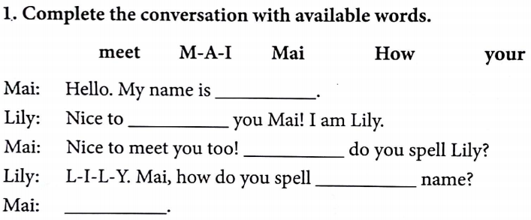
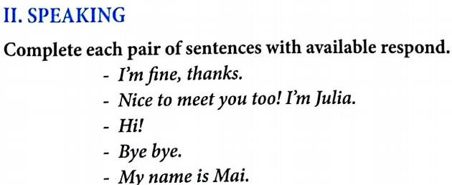
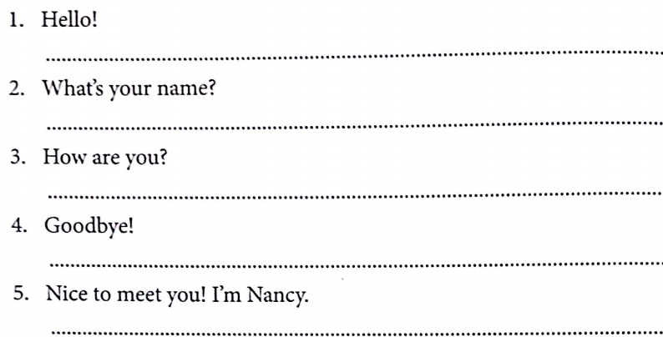
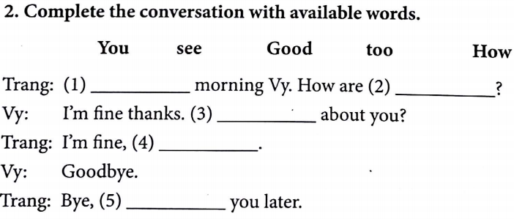
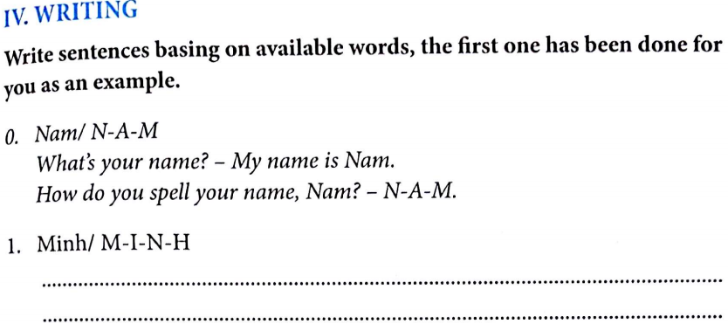
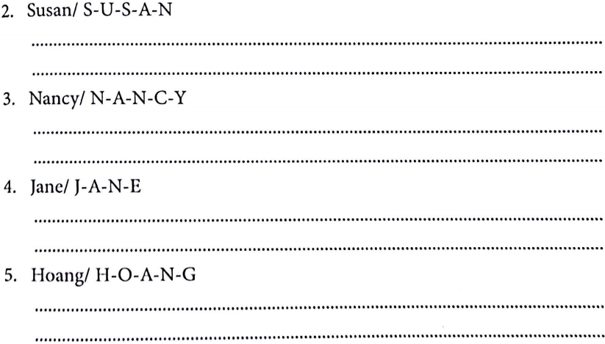
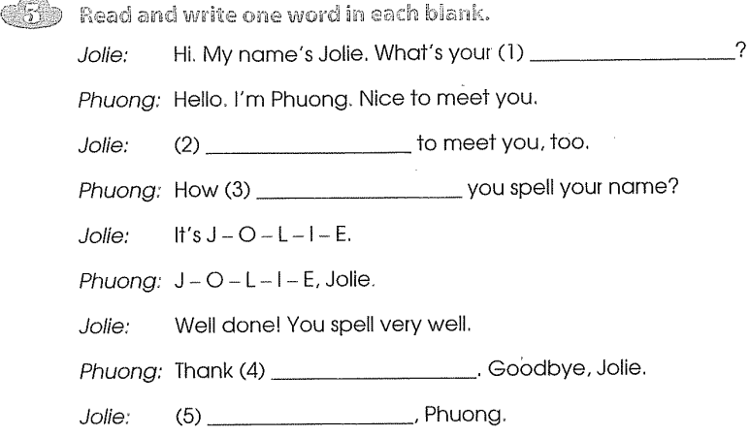
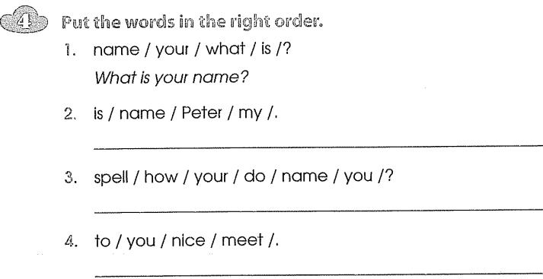

--------------------=   =--------------------
Date of preparation: October 19th , 2019
Date of teaching: October 22nd , 2019
Class: 3A and 3C
Unit 6: STAND UP!
Period 35 Lesson 1( 1, 2, 3)

I. Objectives:
1. Knowledge: By the end of the lesson Ps will be able to: give and respond to instructions.
2. Skills:
- Develop Ss speaking and listening skills
3. Language focus:
- Sentence Partners: be quiet, don’t talk, come here, open your book, close your book, sit down, stand up
- Vocabulary: be quiet, boy, sir, sorry, please, class
II. Teaching aids:
1. Teacher’s: student’s and teacher’s book, pictures, cassette.
2. Students’: books, notebooks, workbooks.
III. Teaching processes:
1. Class organization:
- Greeting
- Checking for the students' attendance.
2. Oral test:
- Have pupils do the exercises.
3. Procedures
Teacher’s activities | Students’ activities
Warm up:  Sing hello song  - 1. Look, listen and repeat.  Ask Ss to identify the characters in the picture on page 40 and what they are saying.  Set the scene “you are going to listen to Mr loc and Ss give and respond to instructions.  Play the recording and asks Ss to listen to the tape.  T asks Ss to listen and repeat in chorus two times.  Call on one pair. One repeats Mr Loc’s part, the other repeats Ss’ part.  Have whole class repeat all the phrases a few times to reinforce their pronunciation. And do the same with the dialogue between Linda and Mai  2. Point, say and do actions  - Have pupils look at pictures on Page 40. Elicit the characters in the pictures and their names.  Teach vocabulary:  Boy  Sir  Sorry  Please  class  check vocab: slap the board  Model sentence: be quiet = don’t talk  come here  open your book  close your book  sit down  stand up  Ask T requests and Ss do.  - Model: Call some Ss request and the others do. Allocate the parts of the characters T and Ss do to the pupils. Ask them to point the pictures and act out the dialogues. Using the pictures in their books. Monitor the activity and offer help. Correct pronunciation errors (stress, assimilation of sounds, intonation) when necessary.  - Call on some pairs to perform their task at the front of the class. The rest of the class observe and give comments.  - Have the whole class repeat all the phrases in chorus to reinforce their pronunciation.  3 Let’s Talk  Ask students to look at the pictures in the book. Ask them to identify the characters in the pictures.  Ask Ss work in pairs. Call some pairs to act out  Correct their pronunciation  *Homework  - Do exercises in workbook, learn by heart the new words | Sing the song  Look at the pictures in the book  Listen and repeat  Look and find out the model sentences  Point the pictures and practise  Pactise in pairs  Do exercises in the workbook

--------------------=   =--------------------
Date of preparation: October 19th , 2019
Date of teaching: October 22nd , 2019
Class: 3A and 3C
Unit 6: STAND UP!
Period 36 LESSON 1 ( 4, 5, 6)

I. Objectives:
1. Knowledge: By the end of the lesson Ps will be able to make and respond to instructions.
2. Skills:
- Develop Ss writing and listening skills
3. Language focus:
- Sentence Partners
- Vocabulary:
II. Teaching aids:
1. Teacher’s: student’s and teacher’s book, pictures, cassette.
2. Students’: books, notebooks, workbooks.
III. Procedures:
Teacher’s activities | Students’ activities
* Warm up  Play game: Simon says  4. Listen and tick  - Have pupils look at pictures 1, 2 and 3 on page 41 of the Student Book. Elicit the identification of the characters in the pictures and the characters’ words. Tell pupils that they are going to listen to the recording and tick the pictures they hear. Guess the answer  - Play the recording 2 times pupils to listen and tick the boxes. Check their guess. Compare the answer with the partner.  - Play the recording again pupils check their answers. T give the answer:  - Ask some questions to ensure pupils’ comprehension of the listening text.  5. Look and write  - Have pupils open their books to Page 41. Get Ss to identify the characters in the pictures and what they are saying.  - Tell Ss that they are going to read and get information to write the missing words in dialogue sentences.  - Ss read silently and complete the dialogues.  - Ss trade their answers within pairs or groups for correction  - Ask Ss to read the answers aloud to the class. The others listen and give comments.  Answers: 1. Open 2. Quiet 3. Close 4. Sit 5. Come  - Stand  - Make some questions to check Ss’ comprehension of the reading text.  Have the whole class read each line of the dialogues chorally to reinforce their pronunciation.  *Consolidation  Asking Ps to focus on the structure once again.  - Retell the content of the lesson.  * Homework  Do exercises in the workbook. Learn by heart the new words and structures. | Play game  Indentify the characters in each picture  Listen and tick  Indentify the characters in each picture  Work in pairs  Listen and sing  Do exercises in the Workbook

--------------------=   =--------------------

